Pharmvel OTC Safety Guide System
A Web and Mobile-Based OTC Medication Safety Guide Application

Submitted by:
Patrick Dorimon

Submitted to:
MR. ARMAN DOYOGAN

PROE 4 — IS Project Management 2 (LAB)
Jose Rizal Memorial State University
March 18, 2026

Introduction
The rapid evolution of technology has significantly impacted various sectors, including healthcare and pharmaceuticals. In recent years, there has been a growing focus on developing innovative solutions to streamline processes within pharmacies, aiming to enhance accuracy, efficiency, and customer satisfaction. One promising area of development is the creation of applications designed to assist pharmacists, pharmacy assistants, and customers in the seamless identification and verification of appropriate medications.
Pharmvel OTC Safety Guide System: A Web and Mobile-Based OTC Medication Safety Guide Application is a digital solution developed to support pharmacies in promoting the safe and effective use of over-the-counter (OTC) medications. The system is designed as both a web and mobile-based platform, providing convenient and accessible drug information for pharmacists, pharmacy assistants, and customers.
The application enhances pharmacy services by delivering comprehensive and reliable information about OTC medicines, including their indications, proper dosage, precautions, possible side effects, and safety warnings. By centralizing this information in a user-friendly system, Pharmvel enables pharmacy staff to provide faster, more accurate, and consistent recommendations while ensuring that customers receive clear and understandable guidance when selecting medications for their symptoms.
In situations where pharmacists are busy or temporarily unavailable, the system serves as a supportive guide for customers by presenting simplified medication instructions, assisting in dosage checking, and alerting users to potential risks and contraindications. This helps reduce medication errors, prevent unsafe self-medication practices, and promote responsible use of OTC products.
Through this system, pharmacies can improve customer education, strengthen medication safety practices, and enhance the overall quality, reliability, and efficiency of healthcare service delivery.
Problem Statement
Despite the increasing availability of over-the-counter (OTC) medications, many pharmacies still face challenges in ensuring their safe and effective use. Pharmacists and pharmacy assistants often manage multiple customers simultaneously, which limits their ability to provide detailed medication guidance. As a result, customers may not receive complete and accurate information regarding proper dosage, precautions, possible side effects, and safety warnings.

In addition, many customers rely on self-medication without sufficient knowledge or understanding of the medicines they use. This can lead to incorrect dosage, misuse of medications, and potential health risks. The lack of accessible, reliable, and easy-to-understand drug information further contributes to medication errors and unsafe practices. Moreover, when pharmacists are busy or temporarily unavailable, customers have limited access to immediate guidance in selecting appropriate OTC medications, while traditional methods of providing information remain time-consuming and inconsistent.
This system addresses the following core problems:
- Limited time of pharmacists and pharmacy assistants to provide detailed guidance due to high customer demand.
- Lack of accessible and reliable information about OTC medications for customers.
- Insufficient understanding of proper dosage, precautions, and side effects among users.
- Increased risk of medication errors and unsafe self-medication practices.
- Absence of immediate support for customers when pharmacists are unavailable.
- Inefficiency and inconsistency in delivering medication information using traditional methods.
Given these challenges, there is a need for a system that can provide accurate, accessible, and user-friendly medication information to support both pharmacy staff and customers. Therefore, this study aims to develop a web and mobile-based OTC Medication Safety Guide System that enhances pharmacy services, improves medication safety, and promotes responsible self-medication practices.

Project Objectives
General Objective
To develop a web and mobile-based OTC Medication Safety Guide System that provides accurate, accessible, and user-friendly information to promote the safe and effective use of over-the-counter medications.

Specific Objectives
- Cross-Platform Accessibility: Develop a responsive web and mobile application using modern frameworks to ensure accessibility on both desktop and mobile devices, providing intuitive navigation for users.
- Comprehensive Medication Database: Implement a robust backend system to store and manage detailed OTC medication information, including indications, dosage, precautions, side effects, and safety warnings.
- Interactive User Guidance: Provide features that allow customers to check proper dosages, receive alerts about potential risks, and access simplified medication instructions when pharmacists are unavailable.
- Enhanced Pharmacy Operations: Enable pharmacists and pharmacy assistants to deliver faster, accurate, and consistent recommendations, improving workflow efficiency and customer service.
- Improved Patient Safety: Reduce medication errors, promote responsible self-medication, and strengthen overall medication safety practices among customers and pharmacy staff.
Project Scope
In Scope
The Pharmvel OTC Safety Guide System project focuses on the development and deployment of a web and mobile-based application aimed at enhancing the safe and effective use of over-the-counter (OTC) medications. The scope of the project includes:
- User Access and Platforms: The system will be accessible via both web browsers and mobile devices (iOS and Android), providing a responsive and user-friendly interface for pharmacists, pharmacy assistants, and customers.
- Medication Information Management: The system will include a comprehensive database of OTC medications, covering indications, proper dosage, precautions, possible side effects, and safety warnings.

- Drug Price Information: The application will display the prices of OTC medications available specifically at Pharmvel pharmacy
- Customer Support Features: The system will provide simplified guidance, dosage checking, and risk alerts to assist customers in selecting and using OTC medications safely.
- Pharmacy Staff Tools: The system will support pharmacists and pharmacy assistants by offering fast and accurate medication information to improve workflow efficiency and service quality.
- Security and Privacy: User data, including personal information and interaction logs, will be securely stored and managed to ensure confidentiality and compliance with data protection standards.
Out-of-Scope
The Pharmvel OTC Safety Guide System will not include the following:
- Prescription Medications: The system will not provide information or guidance for prescription-only medications.
- Clinical Diagnosis or Medical Consultation: The application will not replace professional medical advice, diagnosis, or treatment recommendations.
- Direct Online Sales or Payment Processing: While the system shows drug prices for Pharmvel pharmacies, it will not handle online purchases, payments, or delivery of medications.
- Integration with External Health Systems: The system will not connect to hospital, clinic, or insurance databases.
- Real-Time Monitoring of Patient Health: The application will not track patient vitals, medical history, or provide health monitoring services.
Development Methodology
Pharmvel OTC Safety Guide System will follow the Agile Software Development Methodology, chosen for its flexibility, iterative approach, and emphasis on continuous user feedback. Agile allows the project to adapt to changing requirements and ensures that the system evolves according to the needs of pharmacists, pharmacy assistants, and customers. The development process will begin with planning, which involves identifying project requirements, defining objectives, and prioritizing features. This will be followed by the design phase, where the system architecture, database schema, and user interface for both web and mobile platforms will be created and reviewed. The development phase will proceed in incremental sprints, building core modules such as medication information management, drug price viewing, user guidance, and pharmacist support tools. Each sprint will undergo thorough testing for functionality, usability, and security. Once the system is deployed, continuous maintenance and monitoring will ensure performance optimization and allow implementation of improvements based on user feedback. By adopting the Agile methodology, the project aims to deliver a reliable, user-friendly, and efficient OTC Medication Safety Guide System that meets the needs of both pharmacy staff and customers.
Development Phases
- Phase 1 — Requirements Gathering: Identify and document all functional and non-functional requirements by consulting pharmacists, pharmacy assistants, and customers. Collect information on medication details, drug price display, user guidance, and safety alert need.
- Phase 2 — System Design: Design the system architecture, database schema, user interface (UI/UX) wireframes, and data flow diagrams for both web and mobile platforms.
- Phase 3 — Iterative Development (Sprints): Implement core modules in successive sprints, including medication information management, drug price viewing for Pharmvel pharmacies, user guidance tools, and pharmacist support features.
- Phase 4 — Testing and Quality Assurance: Conduct unit testing, integration testing, usability testing, and security testing to ensure the system performs reliably across web and mobile platforms.

- Phase 5 — Deployment and Evaluation: Deploy the application for web and mobile users, gather feedback from pharmacists and customers, and evaluate system performance against defined objectives.

System Architecture
The Pharmvel OTC Safety Guide System follows a three-tier client-server architecture composed of the following interconnected layers:

Layer | Technology | Responsibilities
Presentation Layer (Frontend) | Web: HTML, CSS, JavaScript, React / Mobile: Flutter | Provides user interface for pharmacists, pharmacy assistants, and customers; displays drug info, prices, guidance, and alerts; ensures responsiveness and usability.
Application Layer (Backend) | Node.js / Express.js | Handles business logic: processes user requests, verifies dosages, generates safety alerts, manages interactions between front-end and database.
Data Layer (Database) | PostgreSQL / MySQL | Stores OTC medication details, Pharmvel-specific prices, user interactions, and pharmacist inputs; ensures data security, integrity, and fast retrieval.

Key Features
The following table summarizes the primary features included in the Pharmvel OTC Safety Guide System:
Feature | Description
User Registration & Login | Secure account creation and login for customers and pharmacy staff, ensuring protected access and personalized experience.
Medication Information | Browse detailed OTC drug information including indications, proper dosage, precautions, side effects, and safety warnings.
Drug Price Display | View prices of OTC medications available specifically at Pharmvel pharmacy for informed decision-making.
User Guidance & Alerts | Receive simplified instructions, dosage verification, and alerts for potential risks or contraindications.
Search & Navigation | Quickly search for medications and navigate through results with filters for faster access to information.
Pharmacist Support Tools | Enable pharmacy staff to provide accurate and consistent recommendations efficiently, improving workflow and service quality.
Cross-Platform Access | Accessible on both web and mobile platforms (iOS and Android) with a responsive and user-friendly interface
Secure Data Management | Store medication details, user interactions, and pharmacist inputs securely, ensuring data integrity and confidentiality.

Database Design
The Pharmvel OTC Safety Guide System uses a relational database to organize and manage essential data efficiently and securely. The database is implemented using MySQL/PostgreSQL, ensuring robust storage, quick retrieval, and scalability for future expansion.
Table | Description
Users | Stores customer and pharmacy staff account information, including login credentials, contact details, and user roles.
Pharmacists | Contains records of pharmacists and pharmacy assistants, their credentials, and work assignments.
Medications | Stores detailed information about OTC medicines, including name, category, indications, dosage, precautions, and side effects.
Prices | Maintains drug prices specific to Pharmvel pharmacies, linked to the Medications table
Dosage Guidelines | Contains proper dosage instructions for different age groups and conditions, linked to medications.
Safety Alerts | Stores warnings, contraindications, and alerts associated with specific medications.
User Interactions | Records customer searches, viewed medications, and alerts received for tracking usage and improving user guidance.

System Diagram
Use Case Diagram
The Use Case Diagram of the Pharmvel OTC Safety Guide System illustrates the interactions between the system and its three primary actors: Customer, Pharmacist, and Admin. Each actor performs specific actions to achieve their objectives within the system
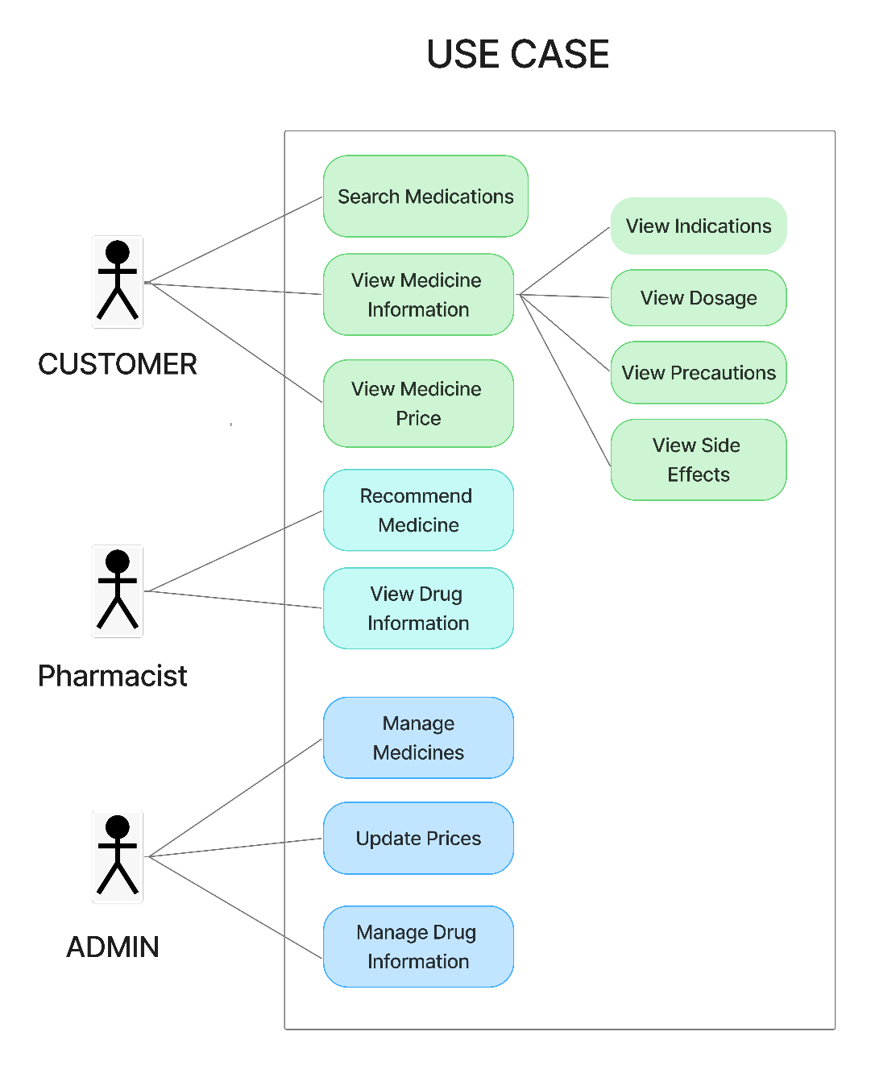

Figure 1. Use Case Diagram – Pharmvel OTC Safety Guide System

Entity Relationship Diagram (ERD)
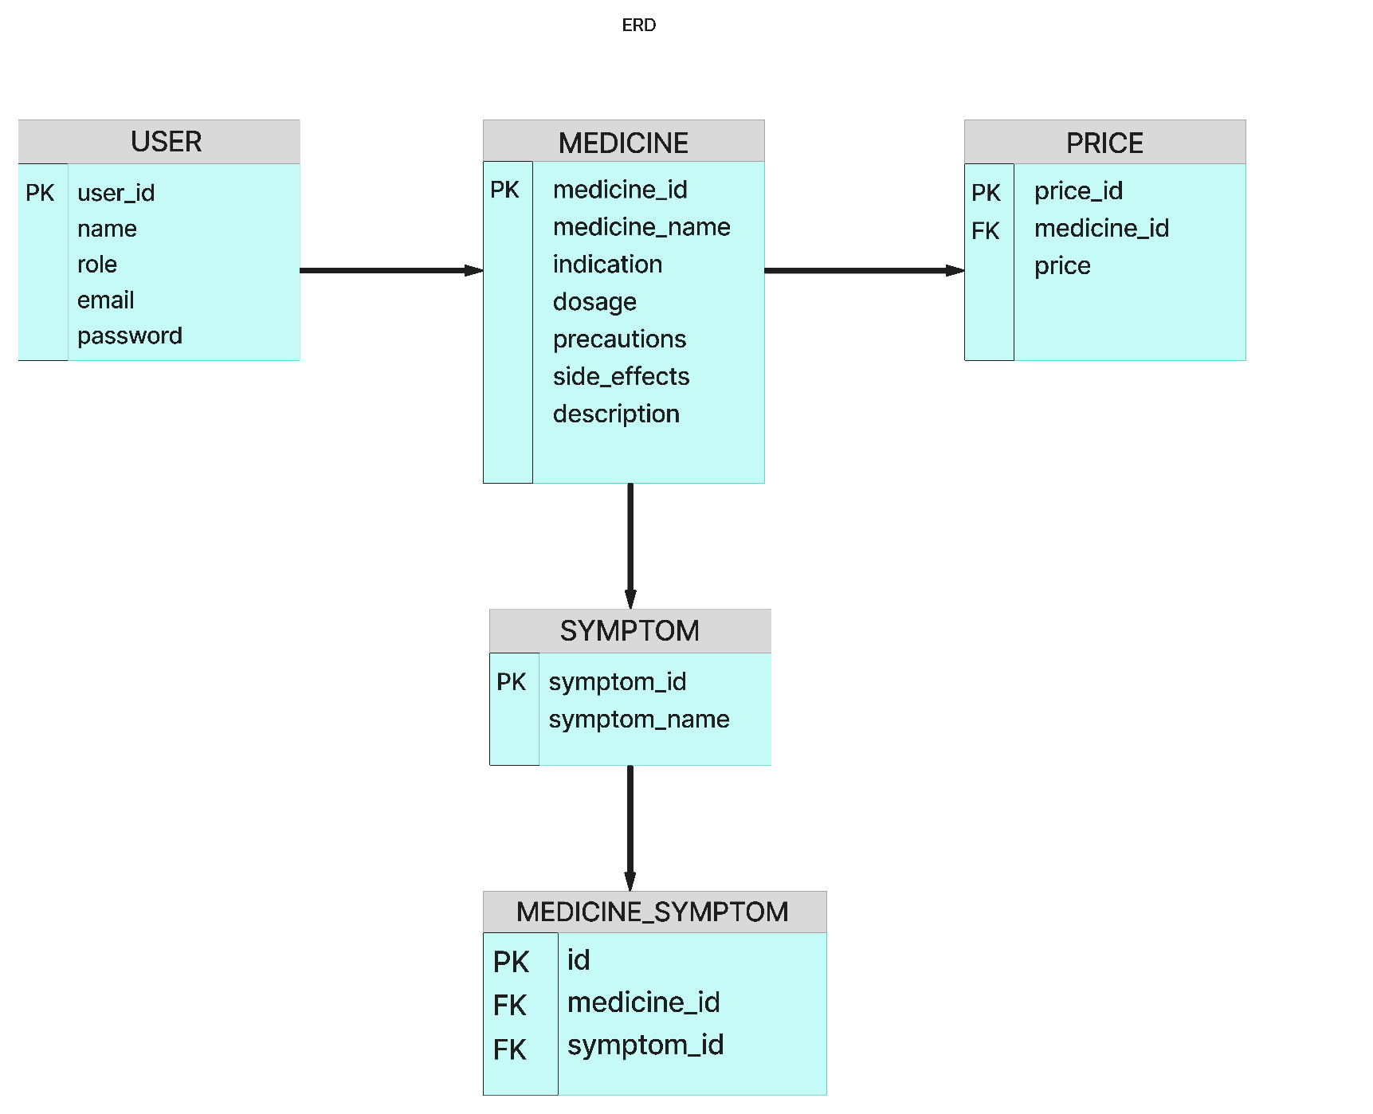
The ERD below depicts the relational structure of the database, showing the entities, their attributes, and the relationships between them.

Figure 2. Entity Relationship Diagram (ERD)

Data Flow Diagram (DFD)
The Data Flow Diagram illustrates how data moves between users, processes, and the database within the system.
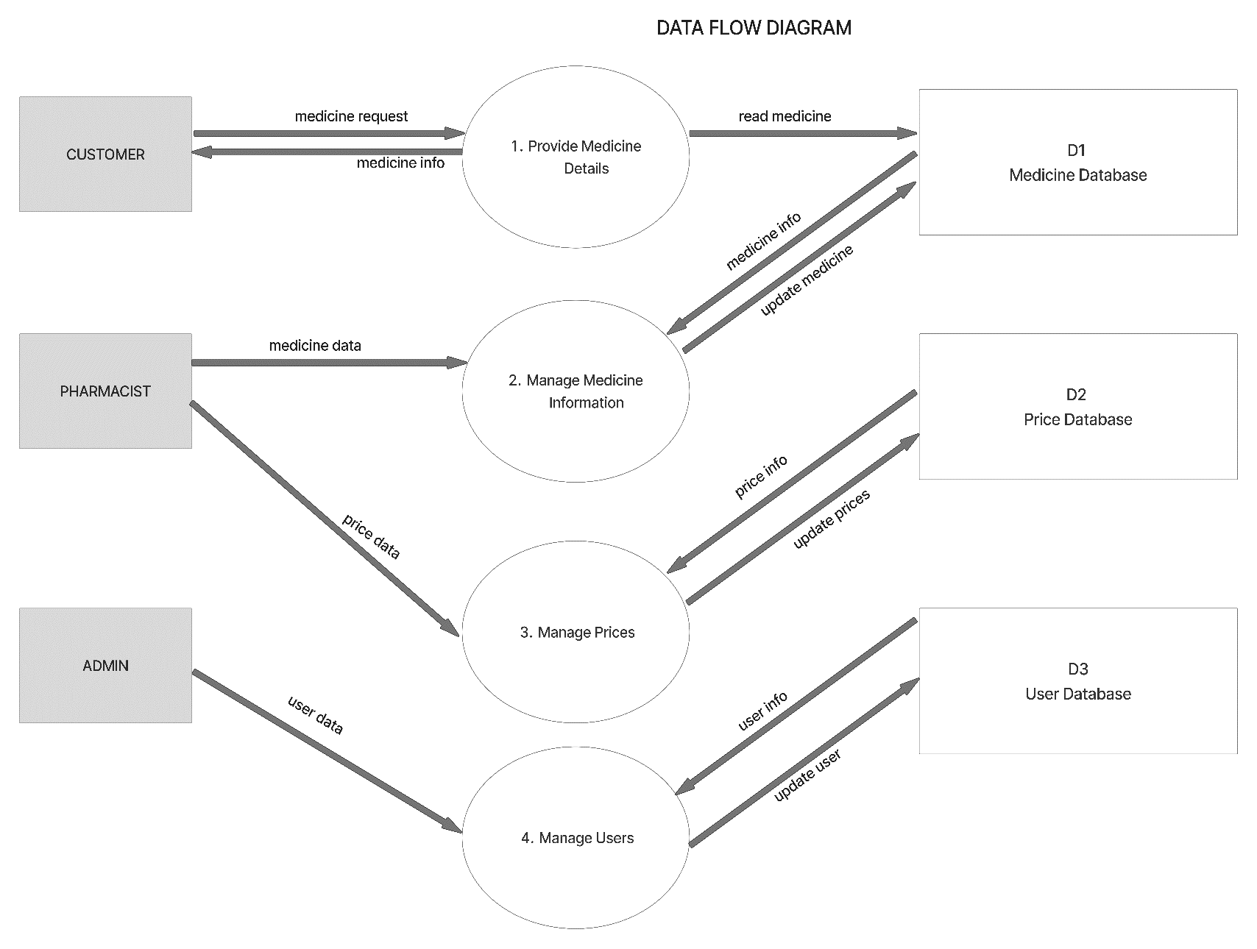

Figure 3. Data Flow Diagram (DFD)

Activity Diagrams
The Activity Diagram illustrates the step-by-step workflow of key Pharmvel processes, including medication verification, dosage checking, and customer guidance.
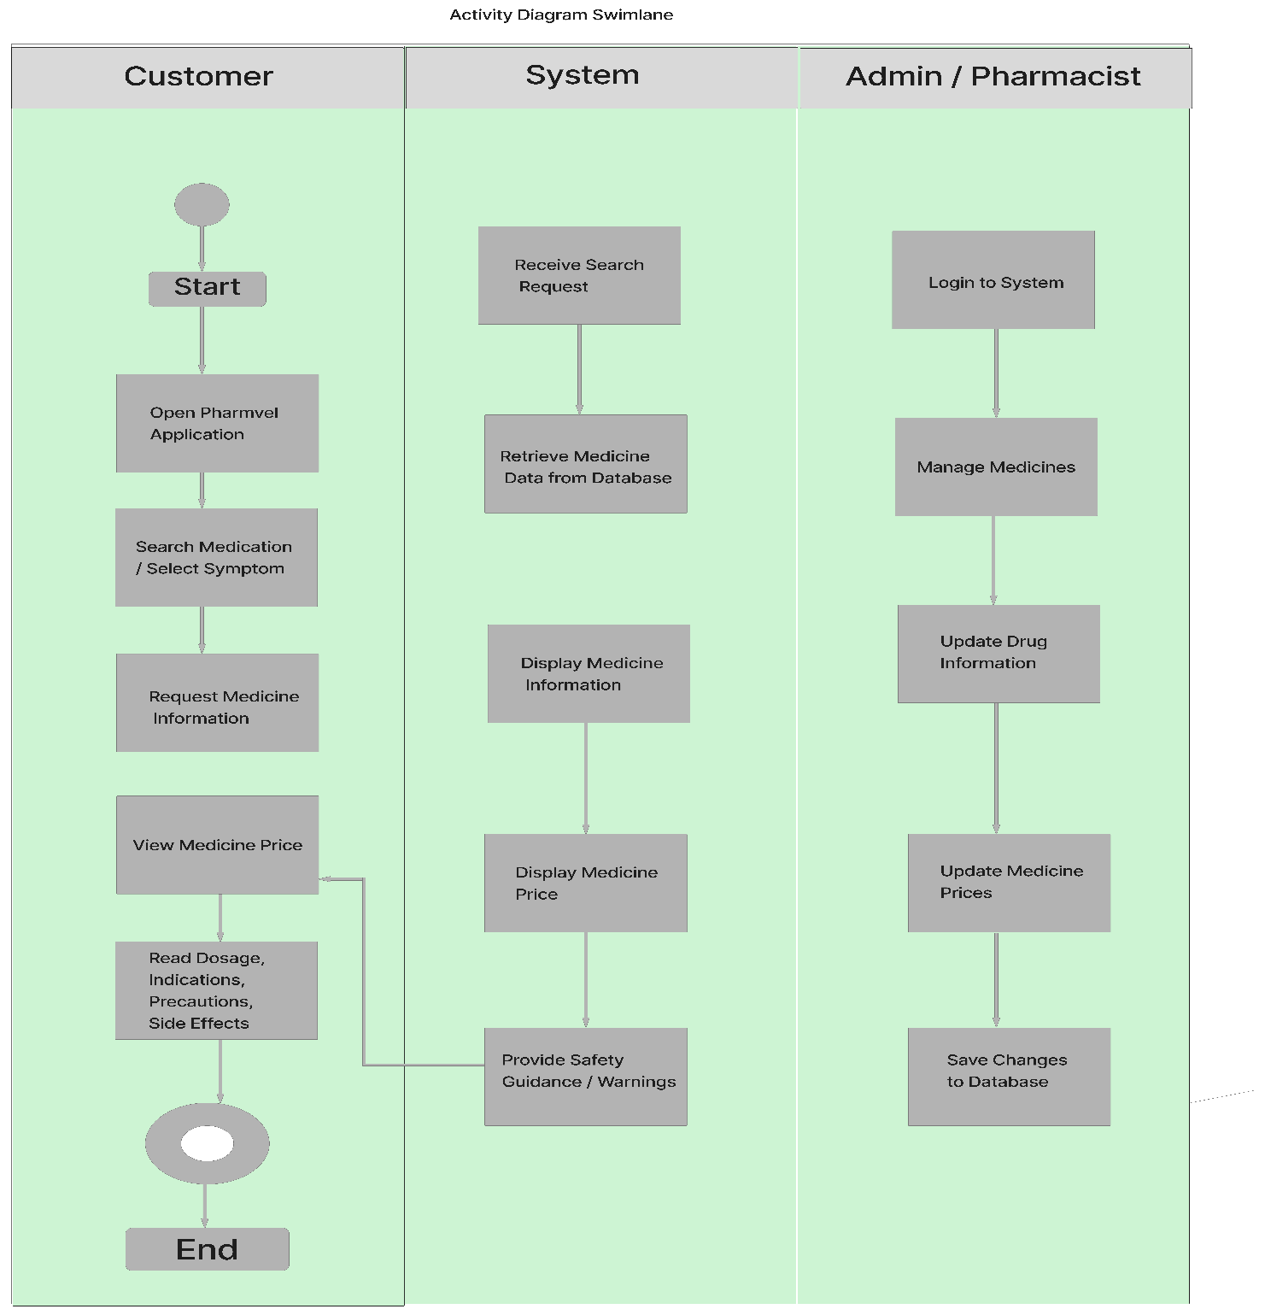

Figure 4. Activity Diagram — Swimlane Diagram

Conceptual Framework
The conceptual framework of the Pharmvel OTC Safety Guide is structured around the Input-Process-Output (IPO) model, showing how user data, medication information, and system interactions are transformed into safe and effective OTC medication guidance.
INPUT | PROCESS | OUTPUT
- Pharmacist, pharmacy assistant, and customer login credentials  - OTC medication data (names, indications, dosage, precautions, side effects)  - Customer symptoms and queries  - User feedback | • User authentication (login/registration)  • Medication search and verification  • Dosage and safety check  • Alerts for contraindications and risks  • Information display for users  • Data storage and management | • Safe and accurate OTC medication guidance  • Simplified instructions for customers  • Dosage recommendations and warnings  • Alerts on possible risks or interactions  • Improved pharmacy workflow and customer safety  • Centralized accessible medication information
Figure 5. Input-Process-Output (IPO) Conceptual Framework
Expected Outcomes
Upon successful development and deployment, the Pharmvel OTC Safety Guide is expected to deliver the following measurable results:
- Reduced Medication Errors: By providing clear dosage instructions and safety alerts, the system minimizes the risk of incorrect self-medication.
- Enhanced Customer Safety: Users receive accurate guidance on OTC medications, including contraindications and potential side effects.
- Improved Pharmacy Efficiency: Streamlined verification and guidance processes help pharmacists and staff manage customer queries faster.
- Increased Customer Education: Simplified instructions and alerts promote responsible use of OTC products.
- Accessible Medication Information: Pharmvel provides reliable drug information for pharmacists, assistants, and customers anytime via web or mobile.
- Data-Driven Pharmacy Decisions: Analytics on user queries and medication usage support better inventory management and service improvements.
Project Timeline
The following table presents the estimated project schedule for the Pharmvel OTC Safety Guide System, organized by development phase:
Phase / Activity | Duration | Target Timeline
Phase 1: Requirements Gathering & Analysis | 1 week | Week 1
Phase 2: System Design (Architecture, UI/UX, ERD) | 1 week | Week 2
Phase 3: Sprint 1 — User Authentication, Medication Database, Symptom Input | 2 weeks | Weeks 3–4
Phase 3: Sprint 2 — Medication Verification, Dosage Checking, Safety Alerts | 2 weeks | Weeks 5–6
Phase 3: Sprint 3 — Customer Guidance Interface, Admin Dashboard, Feedback System | 2 weeks | Weeks 7–8
Phase 4: Testing & Quality Assurance | 2 weeks | Weeks 9–10
Phase 5: Deployment, User Acceptance Testing & Evaluation | 2 weeks | Weeks 11–12

Significance of the Study
The development of the Pharmvel OTC Safety Guide provides meaningful benefits for multiple stakeholders:
For Customers
The system helps customers make safe and informed choices when using over-the-counter medications. It provides accessible guidance on dosage, contraindications, and side effects, reducing the risk of medication errors and promoting responsible self-care.
For Pharmacists and Pharmacy Assistants
Pharmvel streamlines the verification and guidance process, allowing pharmacy staff to provide faster, accurate, and consistent recommendations. It supports workflow efficiency, particularly during busy periods, and enhances the quality of service.
For the Local Community
By promoting safe OTC medication practices, Pharmvel contributes to public health education and encourages responsible self-medication. The system also supports digital inclusion by providing accessible, technology-driven healthcare guidance.
For Future Researchers and Developers
This study serves as a reference for building mobile and web-based healthcare applications. It demonstrates practical implementation of system architecture, user interface design, and database management for medication safety tools.

For the Academic Community
The project illustrates the application of modern technologies to real-world healthcare challenges, contributing to knowledge in mobile app development, pharmacy informatics, and digital health solutions.
Definition of Terms
The following terms are defined as used within the context of the Pharmvel OTC Safety Guide System:
Term | Definition
OTC Medication | Over-the-counter drugs that can be purchased without a prescription. In this study, it refers to medications verified and guided through the Pharmvel system.
Flutter | An open-source UI software development kit created by Google for building natively compiled cross-platform mobile applications from a single codebase.
Node.js | A JavaScript runtime environment that executes JavaScript on the server side, used here to build the backend API handling business logic and authentication.
PostgreSQL | An open-source relational database management system used to store and manage all system data including users, products, and transactions.
JWT (JSON Web Token) | A compact and secure method for transmitting authentication information between parties, used here for user login and session management.
Mobile Application | A software program designed to run on smartphones and tablets. In this study, it refers to the Flutter-built Pharmvel OTC Safety Guide app.
Admin Dashboard | A management interface for authorized pharmacy staff to monitor medications, update data, and track user interactions.
Medication Verification | The process of confirming that a selected OTC medication is safe and appropriate for a customer based on symptoms, dosage, and contraindications.
Dosage Checking | A technology that facilitates secure online payment transactions between customers and merchants during the checkout process.
Safety Alerts | The system’s ability to track, update, and manage real-time product stock levels automatically.
Cross-Platform | Automated messages delivered to a user’s device to provide updates on order status, promotions, and new arrivals.
Agile Methodology | The capability of an application to operate on multiple operating systems. In this study, it refers to the app running on both Android and iOS.
REST API | Representational State Transfer Application Programming Interface — a standard architectural style for designing networked applications and communication between the frontend and backend.

